Database Management System(DBMS): A software used to store, retrieving the data and to maintain the data.

Database: It is collection of interrelated data.

Eg: If hr is a db then: 1. Tables

1. Employees

2. Departments

3. Locations

2. Views

procedures are functions

The operations that are performed on a table are as follows:

1. Projection

2. Selection

3. Join

Types of SQL are as follows:

1. Data Definition Language (DDL)

2. Data Manipulation Language (DML)

3. Data Control Language (DCL)

4. Data Query Language (DQL)

5. Transaction Control Language(TCL)

**DATA QUERY LANGUAGE(DQL):**

* **SELECT:** Used to retrieve data from database.

1. Selection and Projection:

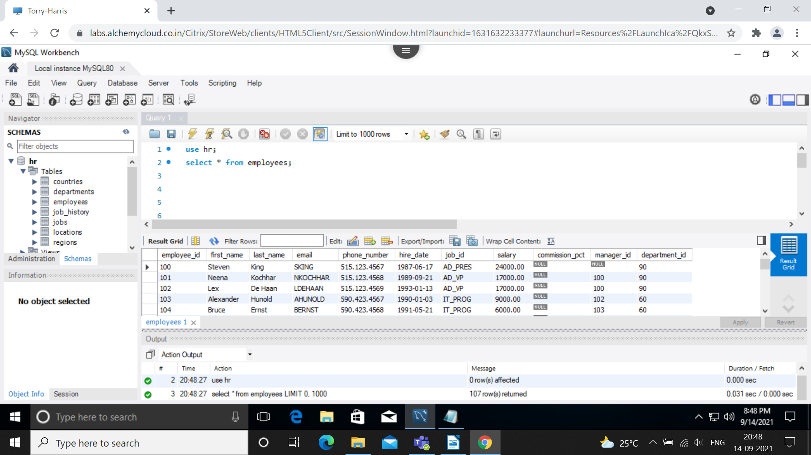

Select statement using arithmetic operators:

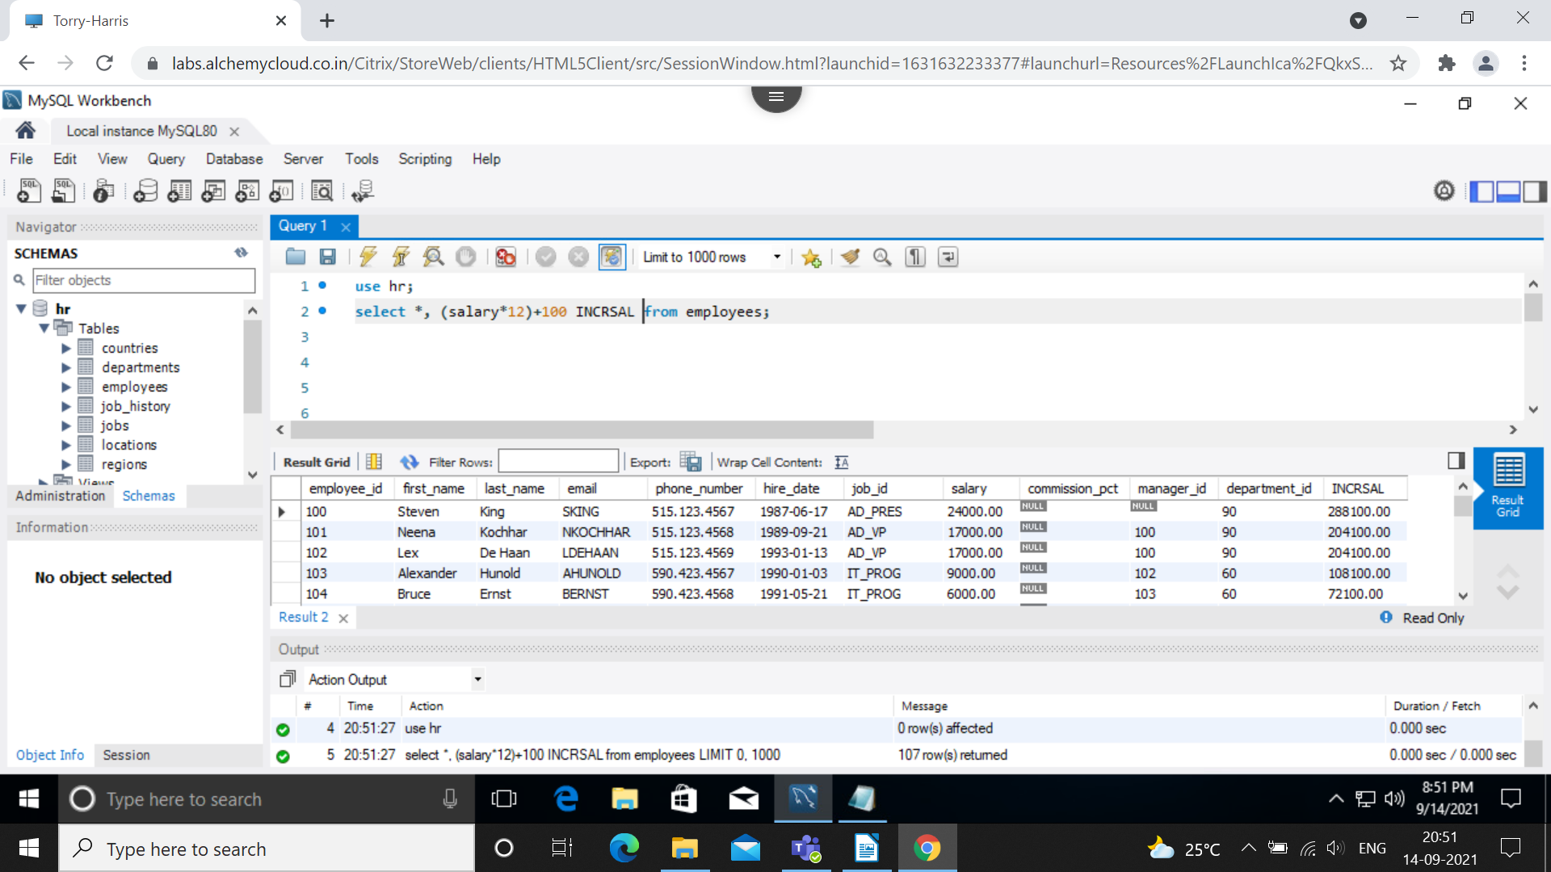

Select statement using concat function:

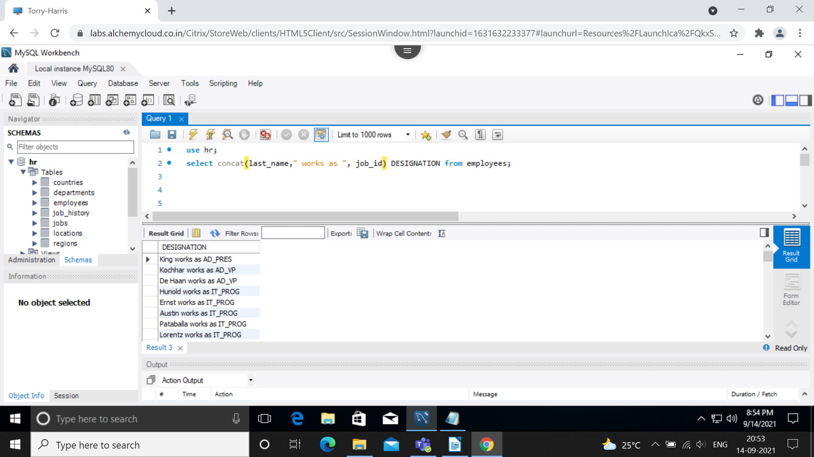

2. Restriction and Sorting:

select employee_id, last_name, department_id from employees where department_id=50;

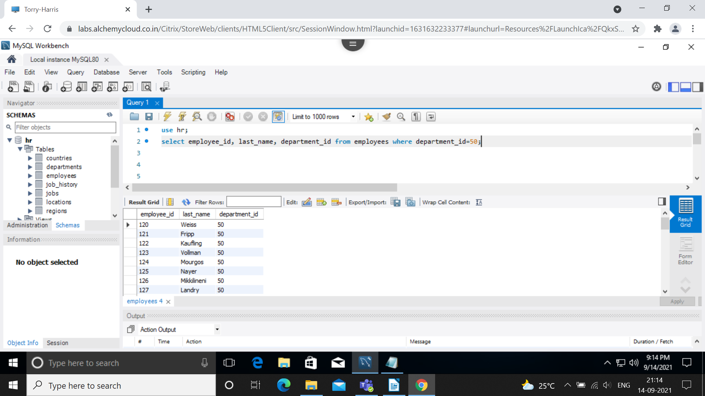

-select employee_id, last_name, department_id, hire_date from employees where last_name=’Vollman’;

-select employee_id, last_name, department_id, hire_date, salary from employees where hire_date=’1997-10-10’;

3. Restrictions with comparison operators:

= : Equal

< > : Not Equal

> : Greater than

< : Less than

>= : Greater than or Equal

<= : Less than or Equal

IN : Matches a values in a list

LIKE : Pattern matching with % and _

BETWEEN : Within a range(Inclusive)

select employee_id, salary from employees where salary <= 8000;

select employee_id, salary from employees where salary >= 6000;

select employee_id, salary from employees where salary = 5800;

select employee_id, salary from employees where salary < > 8000;

select employee_id, salary from employees where salary between 2500 and 5500;

select employee_id, salary from employees where manager_id in(100,101,102);

select first_name, last_name from employees where last_name like ‘S%’ || ‘_o%’||’%o%||’%a’;

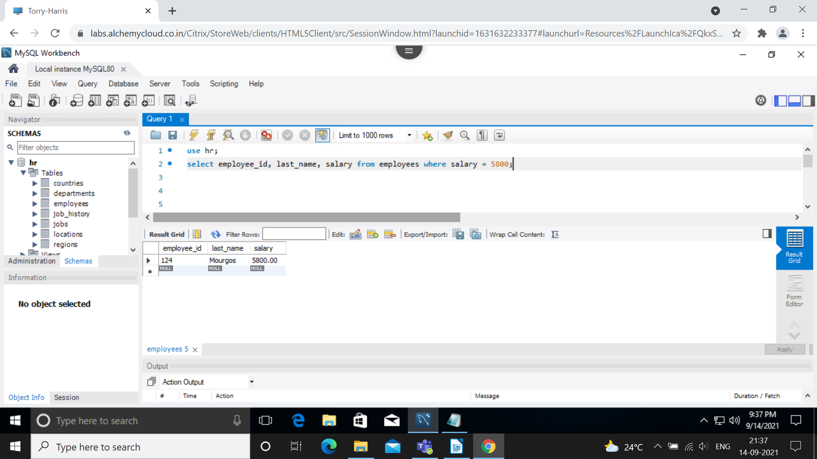

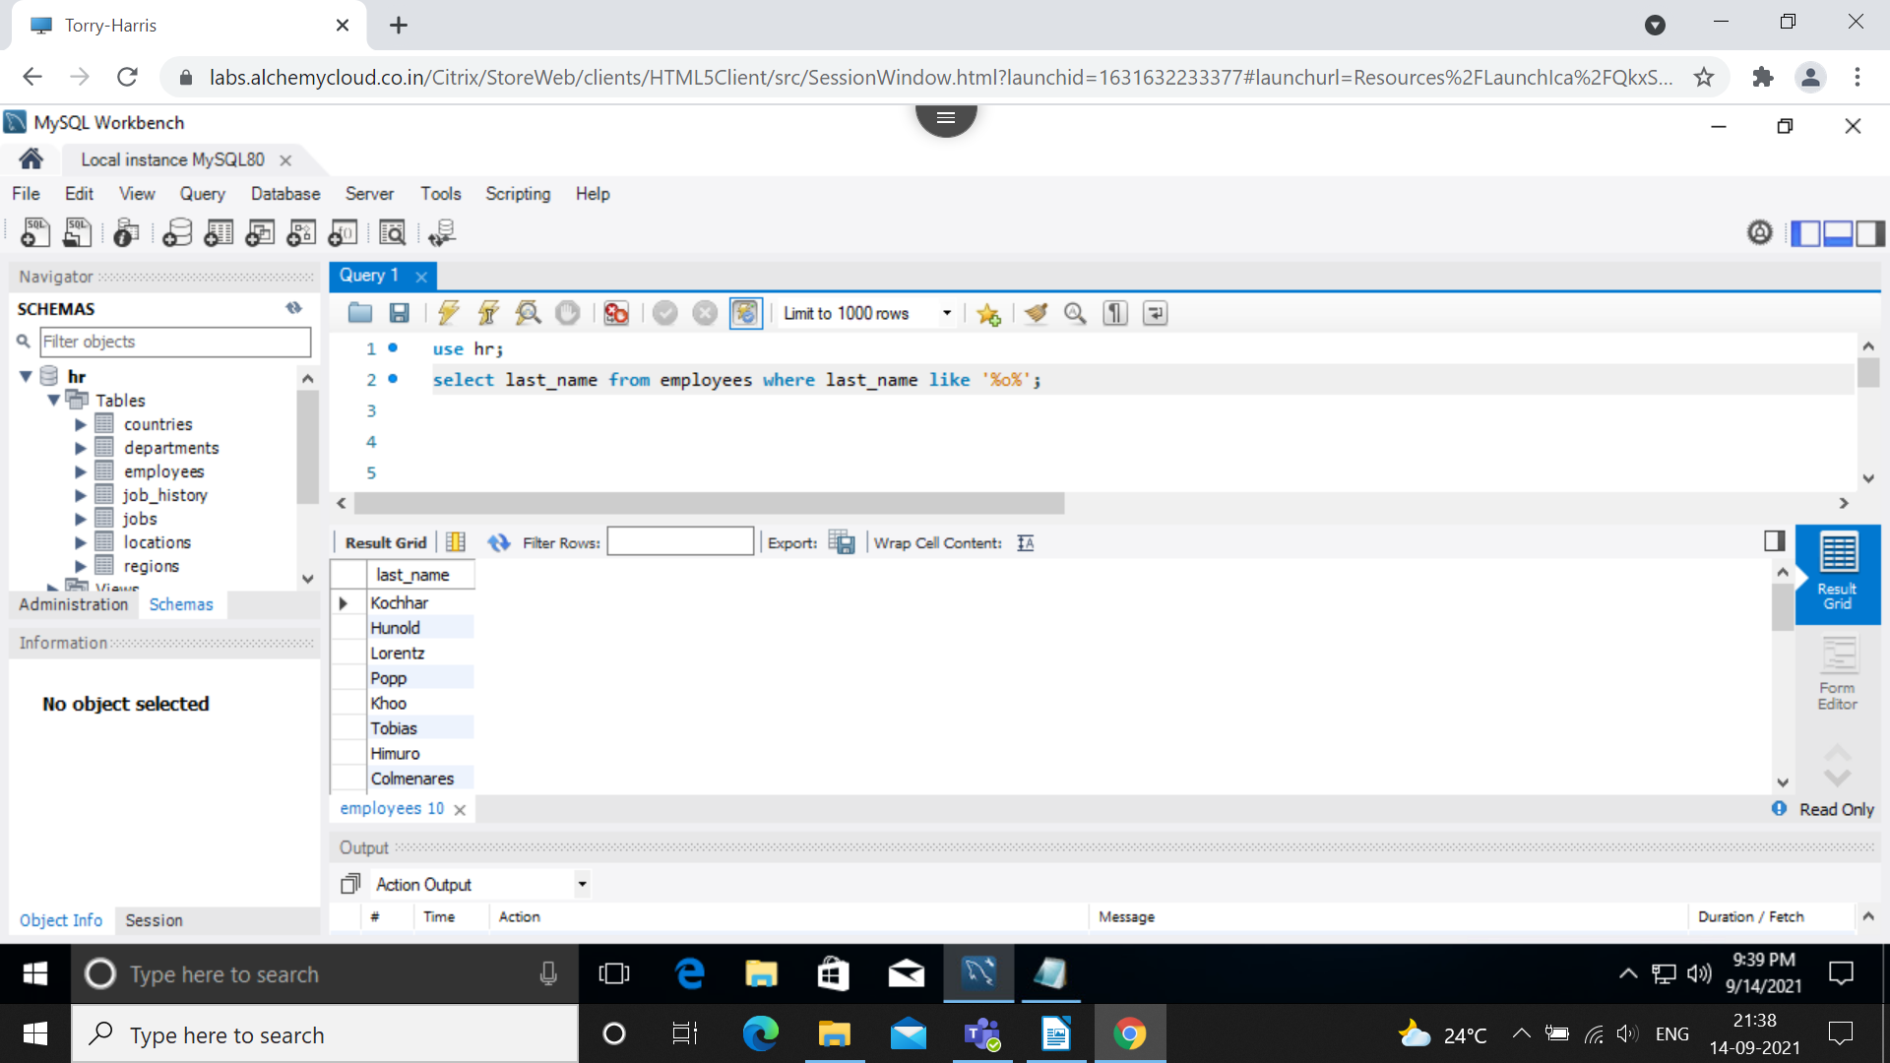

Logical operators:

select employee_id,last_name,job_id,salary from employees where ((salary>=5000) and (job_id LIKE '%MAN%'));

select last_name,job_id from employees where job_id NOT IN ('IT_PROG','ST_MAN');

select last_name,job_id,salary from employees where ((job_id = 'SA_REP') OR (job_id = 'AD_PRES')) and (salary>5000);

select last_name,job_id,salary from employees where (job_id = 'SA_REP') OR (job_id = 'AD_PRES') and (salary>5000);

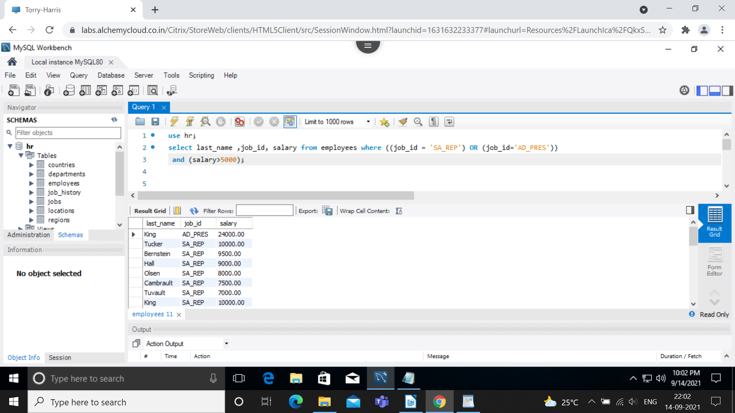

String Functions:

select concat('hello','world');

select substr('helloworld',1,5); -----> hello

select length('helloworld');

select instr('helloworld','w');

select replace('Jack and Jue','J','Bl');

select trim('h' from 'helloworld');

select lpad(salary,10,'*') from employees;

select rpad(last_name,15,'*') from employees;

select employee_id,concat(first_name,last_name) Name, job_id, length(last_name),instr(last_name,'a') 'contains a?' from employees where

substr(job_id,4)='REP';

select substr('helloworld',4);

select job_id from employees;

select last_name, instr(last_name,'a') 'position of the first occurrence of a' from employees;

select upper(concat(substr(last_name, 1,8), '_B84')) from employees where department_id=50;

select employee_id, last_name from employees where last_name='higgins';

select round(45.933,2) from dual;

select truncate(45.937,2) from dual;

select mod(11,2) from dual;

select last_name,salary,mod(salary,5000) from employees where job_id ='SA_REP';

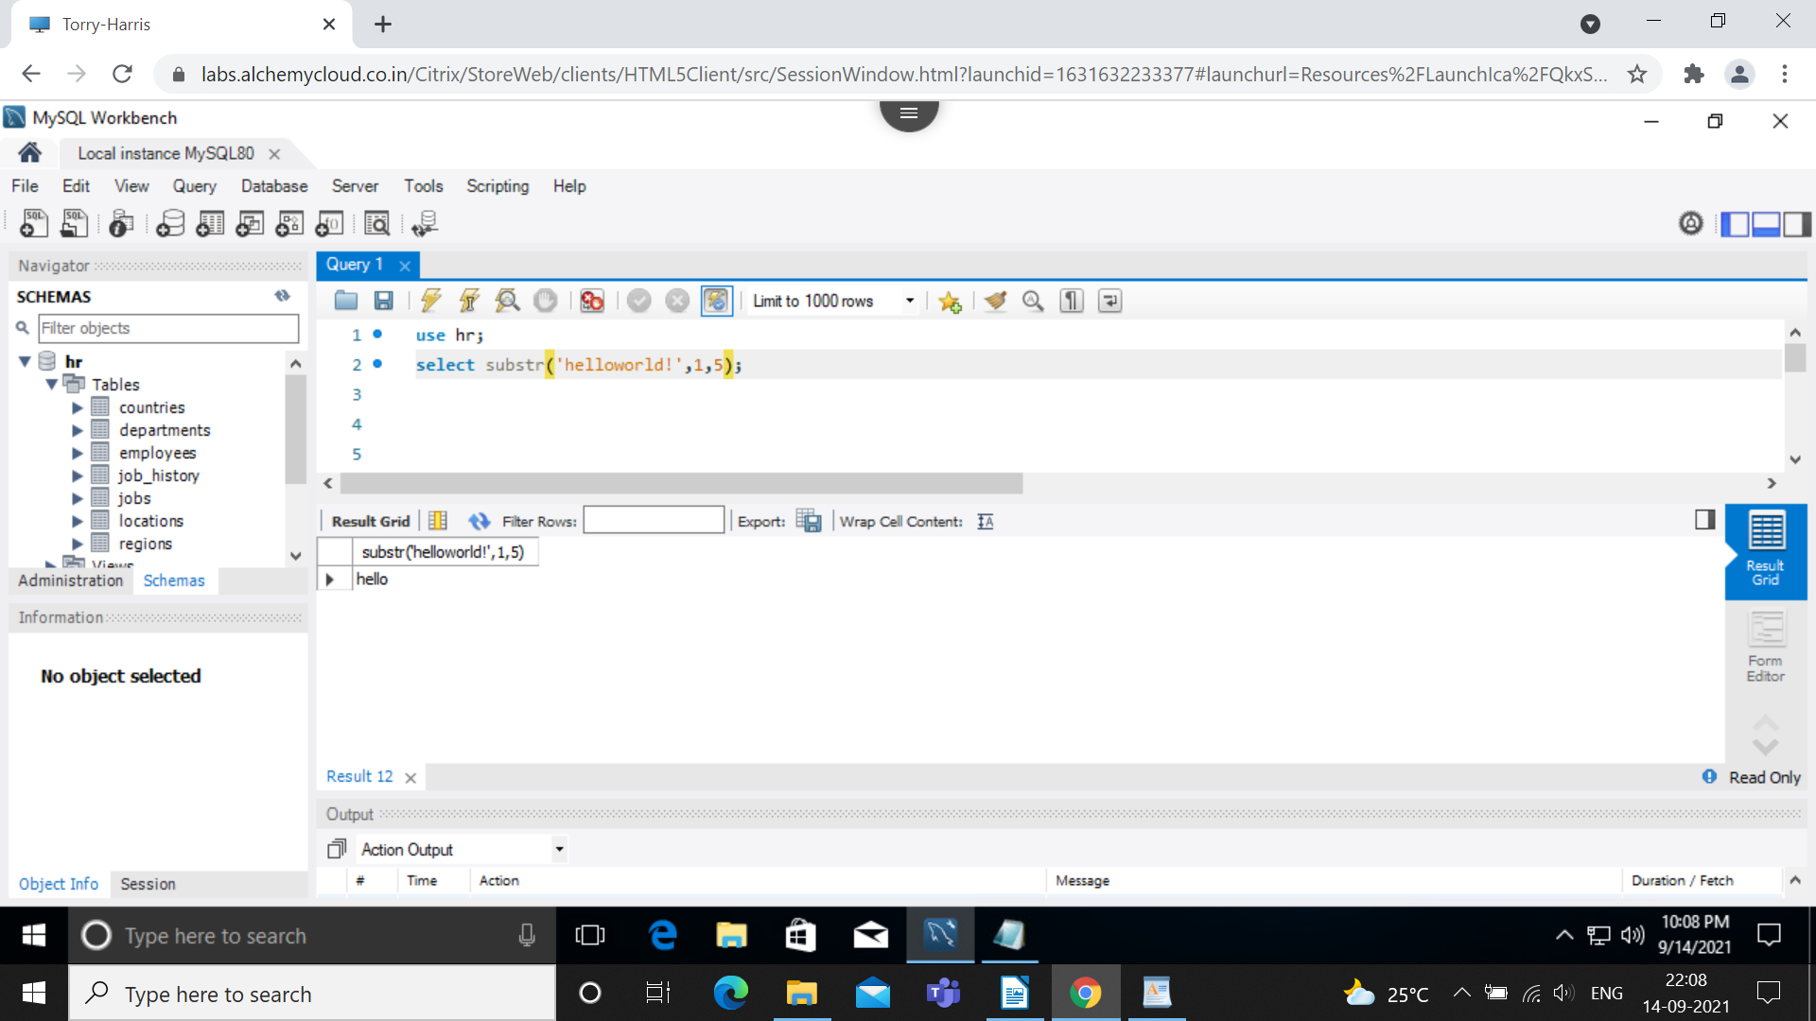

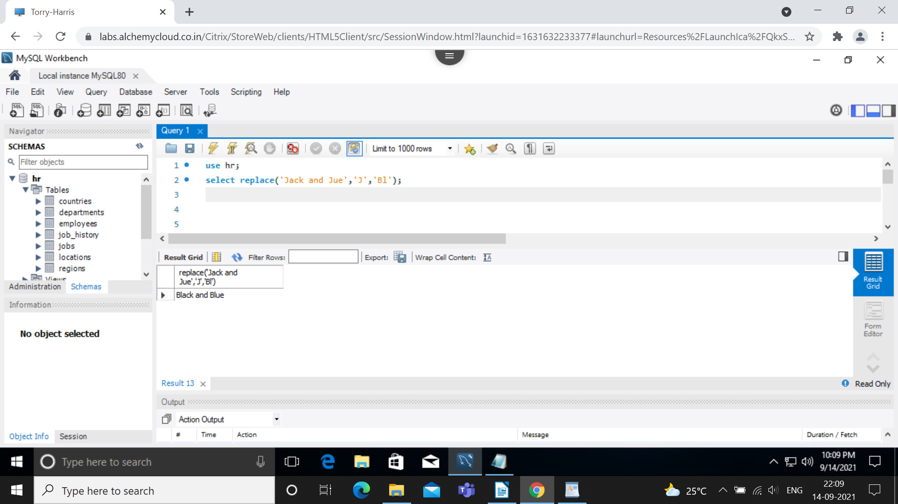

Sorting in Ascending and Descending order:

select last_name,job_id,department_id,hire_date from employees order by hire_date DESC;

select last_name,department_id, salary*12 annualsal from employees order by annualsal;

select last_name,department_id, salary*12 annualsal from employees order by annualsal , last_name desc;

